English
- Develop pleasure in reading, motivation to read, vocabulary and understanding
- Understand both the books they can already read accurately and those they
listen to
- Introduction to capital letters, full stops, question marks and exclamation marks to demarcate sentences
- Compose a sentence orally before writing it
- Re-read what they have written to check that it makes sense
Science – My Body
- Looking at the five senses and what parts of the body we use for them
- Understanding how the senses work through simple experiments
- Labelling parts of the human body

Maths
- Place Value (within 10) including sorting objects; counting objects; representing objects; recognising numbers as words; counting on from any number; 1 more, 1 less; less than, greater than, equal to; comparing numbers; ordering numbers; number lines
- Addition and Subtraction (within 10) including parts and wholes; number sentences; fact families; systematic number bonds; add together; find a part; subtraction on a number line
Phonics – Little Wandle
Review of Phase 2
Review of Phase 3

RE - Christianity
- What do Christians believe about God?
- The Christian Creation story
- Ways Christians believe God wants them to behave

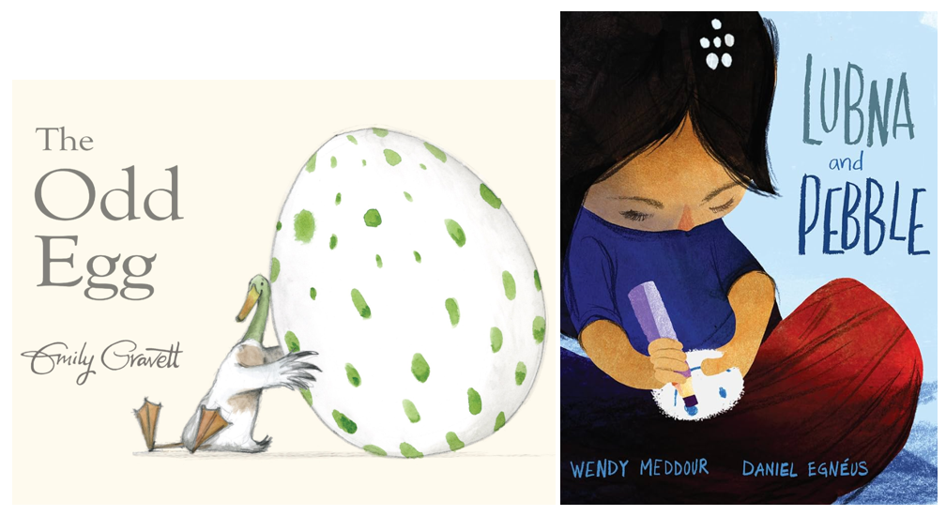

PSHE & RSE – Being Me in My World
- Rights and responsibilities as a member of my class
- Recognising the choices I make and understanding the consequences

Computing
- Online safety
- Chrome books and iPads
- Develop mouse, keyboard and basic computing skills using creative tools
Autumn 1
Cave baby and Lubna and Pebble
Geography – Around the World
- Name and locate the world's seven continents and five oceans
- Use basic geographical vocabulary to refer to key human and physical features
- Use world maps, atlases and globes to identify countries
Music - Senses
- Identifying dynamics, duration, tempo, instruments, mood and pitch
- Performing in time with a pulse, changing tempo, using graphic notation and chanting rhythms
Art – Mark Making
- Holding a pencil correctly for drawing
- Exploring mark making with a variety of mediums and materials
- Learn about the famous artist Paul Klee, imitating his techniques

