Phonics – Little Wandle
Spelling units
Science
Super Scientists
Investigating electricity
Investigating sound
Investigating the wind

Maths
Statistics – bar charts, pictograms, tally charts

Measurement – height, length, mass, capacity, temperature

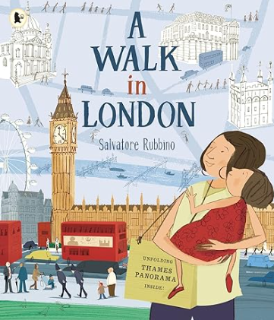
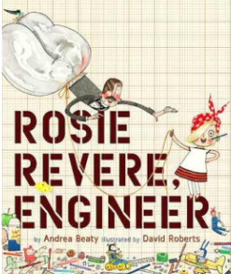
English
Explanation text
Advertisement
Letter of advice
School report card Character description Invention description
Instructions
Persuasive poster
Setting descriptions
Postcards
Diary entry
Cursive handwriting
Computing
Spreadsheets
Adding images, totalling tools, creating tables and block graphs.
Music
Oceans
Identify instruments, pitch, dynamics, rhythm and tempo.

RE
Surrey Syllabus
Is giving better than receiving?

DT
Perfect Pizzas
Examine and categorise a variety of bread-based products.
Design a healthy pizza.
Make and evaluate a food product.
Summer 2
Rosie Revere, Engineer
A Walk in London
History
Seaside Holidays in the Past
Use sources, explore Victorian seaside holidays, compare seaside holidays then to seaside holidays now.
PSHE & RSE
Changing Me
Growing from old to young
Boys’ and girls’ bodies

