Maths
Time – tell the time to 5 minutes

Position and direction

Science
Super Scientists
Investigating the effects of gravity
Investigating how germs are transferred
Investigating our senses and reflexes

Phonics – Little Wandle
Spelling units

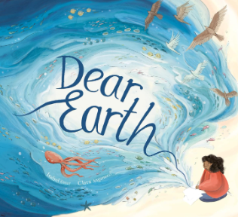
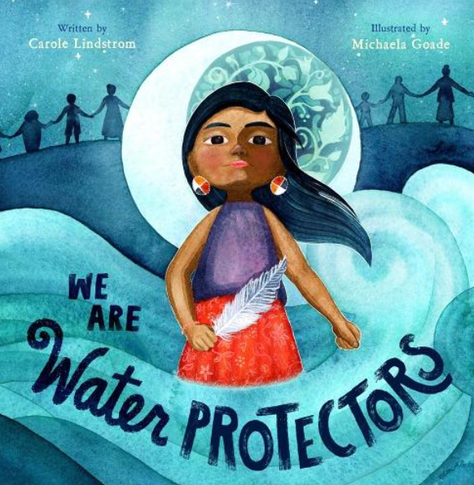
English
Poems
Fact files
Persuasive speeches
Persuasive letters Non-chronological reports
Chronological reports
Travel blogs
Instructions
Music
Four Seasons -Vivaldi, 1723
Sumer is Icumen In, Anon, Medieval

Art
Earth Art
Painting and weaving natural materials to make collages and sculptures.

RE
Surrey Syllabus
Who is Allah and how do Muslims worship him?

Summer 1
We are Water Protectors
Dear Earth

Computing
Questioning
Sorting
Database
Pictograms
Binary Trees

Geography
Map Makers
Compass points
Recognise landmarks and human features
Design and create maps with symbols

PSHE & RSE
Healthy Relationships
Families
Friends and conflict
Physical contact

