Science
Growing plants
How are seeds dispersed?
What conditions affect germination?
How do plants change over time?

Phonics – Little Wandle
Spelling units
Maths
Fractions – half, quarter, third, three-quarters.
Money – pounds, pence, working out change.
Position and direction – describing turns and movements.

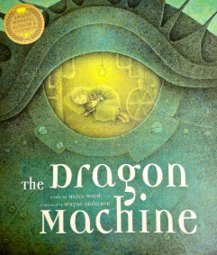
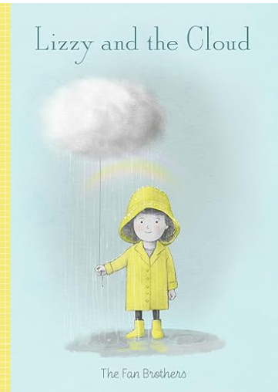
Computing
Uses of technology
Making music
Creating pictures
Music
Toys - The inter-related dimensions of timbre, dynamics, pitch and tempo are explored.

DT
Vehicles
Investigating wheels, axles and chassis.
Make and evaluate a vehicle based on a design.

RE
Surrey Syllabus
Why do Christians call Jesus ‘saviour’?
- How did Jesus rescue Zacchaeus?
- Easter gardens

English
Descriptions
Adverts
Letters of advice
Postcards
Guidebooks
Encyclopaedias
Lists
Subordination
Co-ordination
Conjunctions
Suffixes
Spring 2

Lizzy and the Cloud
The Dragon Machine

History
Florence Nightingale
Her life and achievements.
Similarities and differences between medical care in the Victorian era and now.
PSHE & RSE
Healthy Me
Physical and mental health
Medicine safety
Healthy eating

