Science
Living in Habitats
Living/dead/never alive
Micro-habitats
Food chains
Phonics – Little Wandle
Spelling units
Maths
Multiplication and division

Money

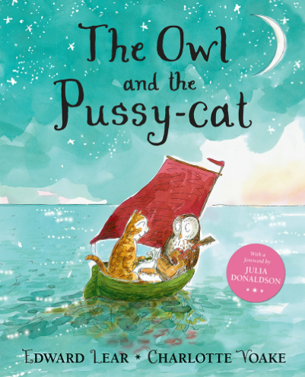
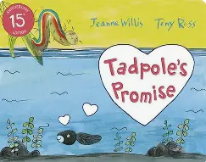
Computing
Coding
Algorithms
Debugging
English
Explanations
Speech bubbles
Setting descriptions
Narratives
Apostrophes
Letters
Interviews
Lists
Instructions
Poetry
Cursive handwriting
Spring 1
Tadpole’s Promise
The Owl and the Pussycat
Music
Great Fire of London
Tempo, dynamics
Notation
RE
Surrey Syllabus
How important is the Prophet Muhammad to Muslims?
Art
Henri Rousseau
Portrait-Landscapes
Recognising key features
Geography
The Arctic
Exploring the climate, physical features, animals and towns and cities in the Arctic Circle.
PSHE & RSE
Dreams and Goals
Success and learning with others.

