Maths
Addition and subtraction (within 100)
Position and direction
Science
Materials
Natural and man-made
Changing shape
Suitability

Phonics
Little Wandle
Bridge to Spelling

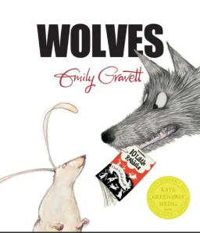
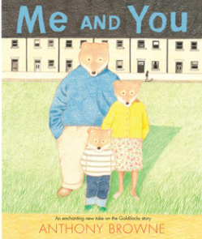
Computing
Presenting information in different ways.
Quizzes, mind maps, fact files
Music
Jupiter
Identifying instruments, dynamics, tempo, pitch
Select and combine resources to respond to a non-musical stimulus.
RE
Surrey Syllabus
Why do Christians believe God gave Jesus to the world?
The Christmas Story
English
Sequel story
Wanted posters
Letters
Retellings
Speech bubbles
Non-chronological leaflet
Captions,
Information writing, Character descriptions Comparisons
PSHE & RSE
Celebrating difference
Stereotypes
Bullying
Diversity

Design Technology
Glove puppets
Sewing skills

Autumn 2
Me and You
Wolves
History
The Gunpowder Plot
The Stuart Era
Guy Fawkes
Bonfire Night

