Maths
Place Value (within 100)
Addition and subtraction (within 100)
Shape
Science
Growth and survival
Lifecycles
Basic needs of animals and plants
Food chains
Phonics
Little Wandle
Review of Phase 5

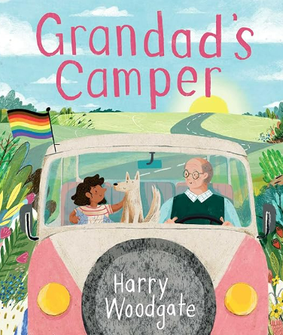
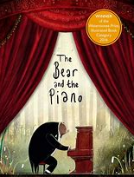
English
Labels
Poems
Interviews
Captions
Postcards
Narratives
Letters
Retellings
Writing in role
Information posters
Computing
E-Safety
Chrome books
Uses of technology
Music
Folksongs
Wellerman, Nathan Evans. Hornpipe, Sir Henry Wood. Dance to your Daddy.
Off She Goes Jig.
Round and Round.
My Bonnie Lies Over the Ocean.
PSHE & RSE
Being me in my world
Belonging, fears and worries, rights and responsibilities, dreams and goals.
Art
Artist : Yayoi Kusama
Japanese contemporary art

Autumn 1
The Bear and the Piano
Grandad’s Camper
RE
Surrey Syllabus
Is it possible to be kind to everyone all the time?
Jesus’s example as the Son of God.
Geography
Where do I live?
To use world maps, atlases and globes to identify the United Kingdom and its countries as well as the continents and oceans.

