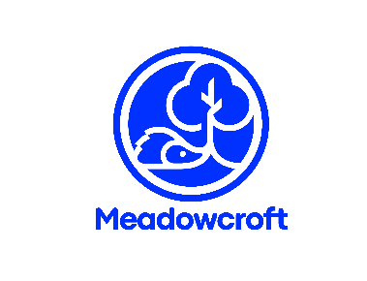
Music at Meadowcroft
The National Curriculum (2014) states: Music is a universal language that embodies one of the highest forms of creativity. A highquality music education should engage and inspire pupils to develop a love of music and their talent as musicians, and so increase their self-confidence, creativity and sense of achievement. As pupils progress, they should develop a critical engagement with music, allowing them to compose, and to listen with discrimination to the best in the musical canon.

Music in EYFS is explored through the Education Programme: The development of children’s artistic and cultural awareness supports their imagination and creativity. It is important that children have regular opportunities to engage with the arts, enabling them to explore and play with a wide range of media and materials. The quality and variety of what children see, hear and participate in is crucial for developing their understanding, self-expression, vocabulary and ability to communicate through the arts. The frequency, repetition and depth of their experiences are fundamental to their progress in interpreting and appreciating what they hear, respond to and observe.

Early learning goals that link to music:

EYFS Expressive arts and design

ELG Being imaginative and expressive

- Sing a range of well-known nursery rhymes and songs.
- Perform songs, rhymes, poems and stories with others, and – when appropriate – try to move in time with music.

What this looks like in the Early Years…
- Access a range of percussion instruments indoors and outdoors, and are taught their names.
- Explore how sounds can be changed and learn the related vocabulary eg loud/quiet, fast/slow.
- Build up a repertoire of songs and rhymes through opportunities to sing on a regular basis.
- Listen to a range of music.
- Encouraged to move in response to music.

Music is planned and taught following the scheme Get Set 4 Music.


